HP0G48 IT in Business: Advanced Database   
**Relational Database Design Car Care Garage**

Class Name: Zhang Wuzhuohao  
  
  
Table of Content

Introduction 1

Section 1: Analysing the existing database 1

Section 2: Problem solving in relational database 1

Section 3: New database design 2

Section 4: Database tools 3

Conclusion 4

Appendix 5

# Introduction

This document provides a detailed overview for database professionals about the design and functions of the proposed database system. It explains the relationships between tables, key fields, and specific settings to ensure effective data management and retrieval based on the organization’s needs.

# Section 1: Analysing the existing database

**Deletion Anomaly:** A deletion anomaly occurs when the removal of a specific record unintentionally leads to the loss of other critical data within the database. This problem arises due to the flat-file database structure, where multiple types of information are stored redundantly within the same table or record. For instance, deleting one order might simultaneously remove all information about that customer or car model. This violates referential integrity, as the vital data of specific sales order is deleted, this might lead to the loss of valuable information. (See in pic 1)

**Duplication Anomaly:** A duplication anomaly, also referred to as a redundancy anomaly, arises when the same information is unnecessarily repeated across multiple records in the database. In flat-file databases, this is a common problem leads to inefficient and inconsistent data management. This reflect on the inconsistencies of data on domain integrity, additionally, user-defined integrity is breached because data redundancy undermines the accuracy and consistency in business processes. (See in pic 2)

# Section 2: Problem solving in relational database

**Deletion Anomaly:** Creating independent tables to store the data entity of customer, car make, and salespersons is an appropriate solution to ensure that deleting a sales order does not result in the loss of information. The relationships between these tables are maintained through the use of foreign keys, which link order table with other tables. Additionally, these foreign keys enforce referential integrity by keep all linked tables remain consistent and accessible even if an order is removed. (See in pic 3)

**Duplication Anomaly:** Based on the relational database, the repeated data such as car and salesperson information are separated from each sales order in the flat-file database. Each unique data entity is stored in a independent table, ensuring that information is recorded only once to avoid the same data information stored in different places. (See in pic 4)

# Section 3: New database design

Suffixes + descriptive + underscope separation entities were used as a combination to name data field. The **car table** contains attributes that describe vehicles available in the database. The primary key for this table is “car_id_car” (format “car” 000), uniquely identifying each car. The **customer table** stores information about customers, with “customer_id_customer” (format “cus”000) as the primary key. The **salesperson table** describes the staff responsible for sales, with “staff_id_salesperson” (format “stf”000) as the primary key. The “order_id_order” (format “ord” 000) is a primary key in order table, moreover, “car_order”, “customer_order”, and “salesperson_order” are the foreign key of “order_id_order”. The input mask of telephone number was designed in "("0###")"###"-"#### according to the input data fields refers to the consistence of text and number as data type. The input mask of registration number was designed in “LL00LLL”. The start date in **salesperson table** was in the format of short date. There was a hyperlink to document for the cv of salesperson. The calculation field was designed to perform in double with two decimal places for some data field such as price, basic salary, and VAT requires calculation with money. The lookup field was also input to assist the lookup on car makes. (See in pic 5)

Entity‑Relationship Diagrams (ERD) explain the relationship of each entity with each other in different stages. Each bloc of entity was identified and linked according to their data field and functions. (See in pic 6) The data fields were generated according to their attribute (car, customer, salesperson, and order). (See in pic 7) The entity of car, salesperson, and customer have the relationship with the entity of order. The relationship between these entities and order is one to many. (See in pic 8)

Make‑Table Query: This query consists of the data field from customers table and car table (named as Customer Info by Car Make). The purpose of this query is to output the result that meet the customers’ demands and have the capability to export the result to external databases.

Parameter Query: This query consists of the data field from customers table and salesperson table (named as Customer Info by Salesperson). The purpose of this query is to display the customer’s information of salesperson as the user input the salesperson’s ID.

Calculation Query: This query consists of the data field from order table and salesperson table (named as Commission by Order). The purpose of this query is to calculate the commission based on the sales order. The commission for each order is calculated as the order price after deducting VAT, multiplied by the commission rate of the salesperson handling the order. $Commission=(Price-VAT)×Rate$

Total Query: This query is a simple query which required the call from the field in Commission by Order. The purpose of this query is to summarize the total commission amount for each salesperson.

# Section 4: Database tools

Microsoft Access is a robust relational database management system (RDBMS) by Microsoft, enabling efficient database design and management. It supports creating tables, defining relationships, and enforcing data integrity through VBA. Its query builder facilitates SQL-based data manipulation, while form and report tools enhance user interaction and data visualization. Access is a powerful tool for developing small to medium-sized projects.

Converting Database: Converting databases to the .accdb format in Microsoft Access enhances compatibility and performance. The process involves converting an Access 2000 or Access 2002 - 2003 database (.mdb) to the .accdb format via selecting “Save As” and saving it as .accdb while addressing features like security or replication limitations. Moreover, the Access 97 database (,mdb) is also able to be convert into .accdb format.

Compacting and Repairing: The Compact and Repair feature in Microsoft Access optimizes database performance by reducing file size and fixing corruption. There are few actions that are required before a compact and repair operation. Compacting eliminates unused space, enhancing the performance, while repairing mitigates the risks of the data base corruption.

# Conclusion

In conclusion, the database structure described in this document is essential for improving data accuracy and access. By using organized queries and following best practices in table design, the system improves overall performance and meets the specific needs of the organization and its users.

# Appendix

pic 1

pic 2



pic 3

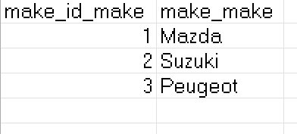

pic 4

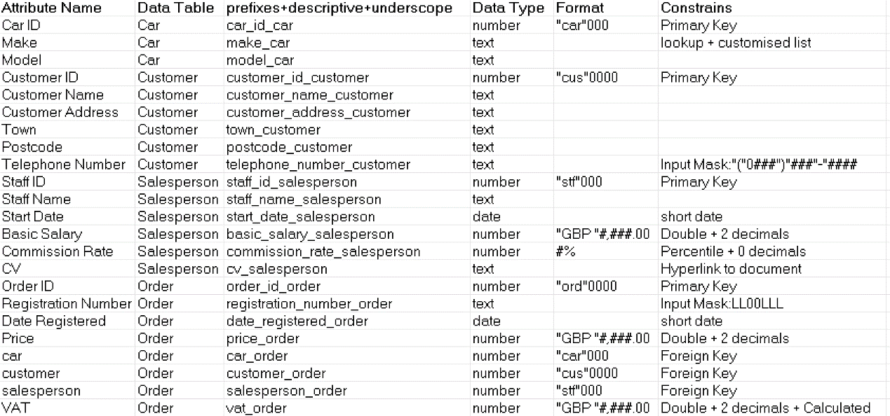

pic 5

pic 6

pic 7

pic 8